**Livewire Installation**

**1. Install The Package**

composer require livewire/livewire

D:\wamp64\www\LivewireTest>**composer require livewire/livewire**

./composer.json has been updated

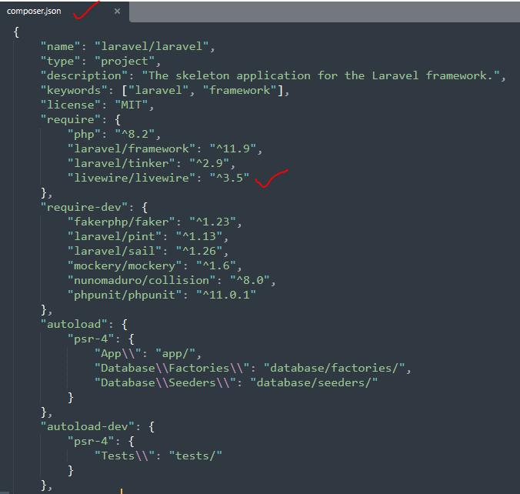

**Basic Tags Livewires**

## [Include The Assets](https://laravel-livewire.com/docs/2.x/installation#include-js)

@livewireStyles

@livewireScripts

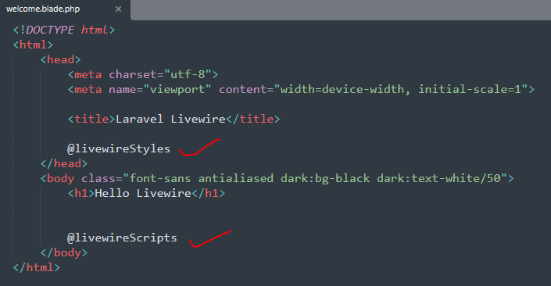

**Livewires Component Create**

<https://laravel-livewire.com/docs/2.x/quickstart>

## [Create a component](https://laravel-livewire.com/docs/2.x/quickstart#create-a-component)

Run the following command to generate a new Livewire component called counter.

php artisan make:livewire counter

D:\wamp64\www\LivewireTest>php artisan make:livewire counter

COMPONENT CREATED.

CLASS: app/Livewire//Counter.php

VIEW: D:\wamp64\www\LivewireTest\resources\views/livewire/counter.blade.php

Running this command will generate the following two files:

**(1) app🡪Http🡪Livewire🡪Counter.php**

**Note: Laravel 11 me Direct app me hota h.**

**app🡪Livewire🡪Counter.php**

|  |
| --- |
| namespace App\Http\Livewire;    use Livewire\Component;    class Counter extends Component  {  public function render()  {  return view('livewire.counter');  }  } |

Old version call in livewire

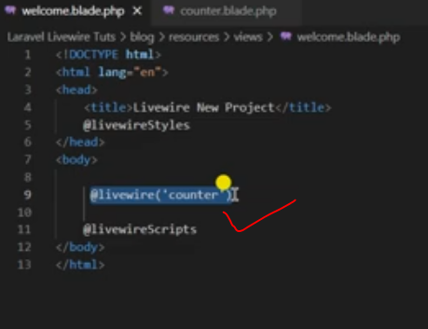

**(2) resources🡪views🡪livewire🡪counter.blade.php**

|  |
| --- |
| <div>  <h1>**Hello Livewire World!**</h1>  </div> |

**Welcome.blade.php**

Blade file se livewire view file ko call karaya

<livewire:counter/> New Method

@livewire(‘counter’) 🡪**Old Method**

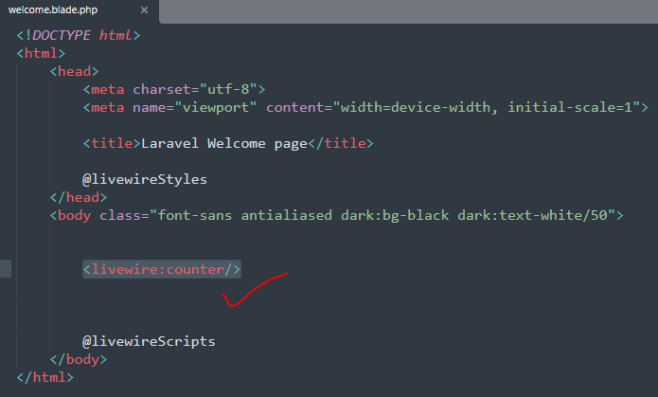

Livewire🡪**counter.blade.php**

